 | 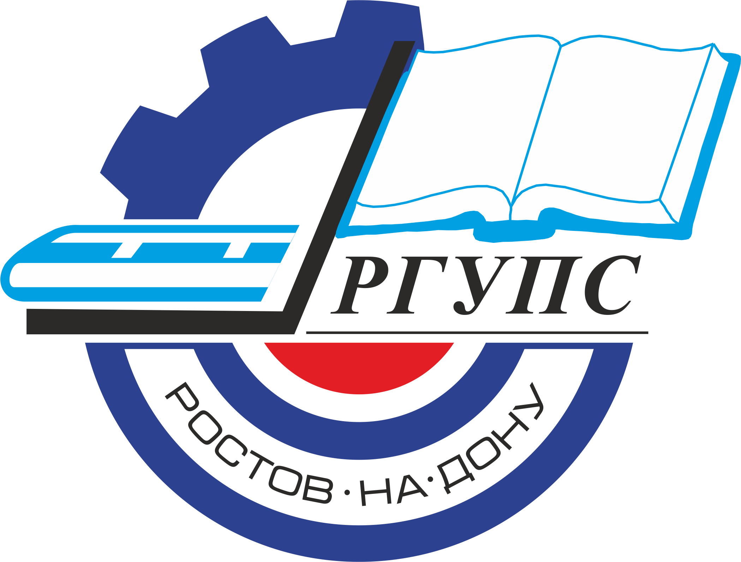 | Rostov State Transport University
International Scientific Conference
"Mechanics, Friction and Wear in Transport System"
(May 24-25, 2021, Rostov-on-Don)

Dear colleagues!
We are pleased to invite you to attend the International Scientific Conference "Mechanics, Friction and Wear in Transport System".
The organization of the conference is the Federal State Budgetary Educational Institution of Higher Education "Rostov State Transport University". The conference will be held in Rostov-on-Don on May 24-25, 2021.
The purpose of the conference is to present the achievements of Russian and foreign scientists and specialists in the field of mechanics and tribology in relation to modern transport systems.
The Organizing Committee of the Conference is pleased to invite you to attend the conference and publish papers which are of significant scientific interest, original and previously unpublished. After reviewing, all materials will be published in the journal and will be submitted in SCOPUS for indexing.

MAIN DIRECTIONS OF THE CONFERENCE
1. Mechanics of transport systems.
2. Problems of friction and wear in transport systems.
3. Lubricants for transport systems.
4. New wear-resistant materials and strengthening technologies.

IMPORTANT DATES:
Conference May 24-25, 2021
Paper Submission in English May 20, 2021
REGISTRATION FEE FOR OUTSIDE PARTICIPANTS – 12000 rubles.

ORGANIZING COMMITTEE OF THE CONFERENCE:

Chairman:
V. I. Kolesnikov – Academician of the Russian Academy of Sciences, President of RSUPS

Vice-chairman:
- N. Gudа – Vice-Rector for Science;

Organizing Committee Members:

V. N. Noskov – Director of the Scientific-Research Department;
A. A. Nazaretov – Deputy Director of the Scientific-Research Department;
A.V. Sidashov – Associate Professor of RSTU;
P. G. Ivanochkin – Professor of RSTU;
D. S. Manturov – Head by the RSTU laboratory;
E. S. Novikov – Junior Researcher RSTU;
O. A. Belyak – Associate Professor of RSTU;
A. I. Voropaev – Director of the Research and Testing Center "Nanotechnologies and Tribosystems".

SUBMIT PUBLICATIONS ПОДАЧА ПУБЛИКАЦИЙ
The submitted materials should be original and previously unpublished and should be associated with one or more scientific scope of the conference. All submitted materials are analyzed by the Organizing Conference Committee for quality, novelty and scientific accuracy. All manuscripts submitted are subject to peer review process. The negative review with the reasons for refusal or the positive decision is sent to the author by e-mail. We ask you to send all questions about the verification procedure to the contact address.
MANUSCRIPT PREPARATION GUIDELINES
- The minimum size is 6 pages plus References (font 10, single spacing).
- Only "portrait" page format.
- The structure of the text of the article must comply with the IMRAD standard(https://xn--80aegcaa6cbngm5a6c1ci.xn--p1ai/razbor-struktury-stati-imrad/)
- Requirements for images
- All images must be clear and legible.
a. If you are submitting an article in English:
– absence of Cyrillic characters in the paper (including formulas, graphs, diagrams, diagrams, screenshots of programs and any images) !!!

If you submit paper in Russian:
– all formulas, graphs, diagrams must be editable for translation.
- The sources of borrowing of all images should be indicated, if they are not copyright. The borrowing source is indicated in the figure caption.
- All papers will be checked for plagiarism. In case of detection of plagiarism (as well as self-plagiarism), the authors will be refused to resubmit the paper.

The papers are considered only in English.

CONTACTS
Веб сайт конференции: http://www.rgups.ru/science/doktorantura-i-aspirantura-kon-1388/
E-mail: mti@rgups.ru

