 | 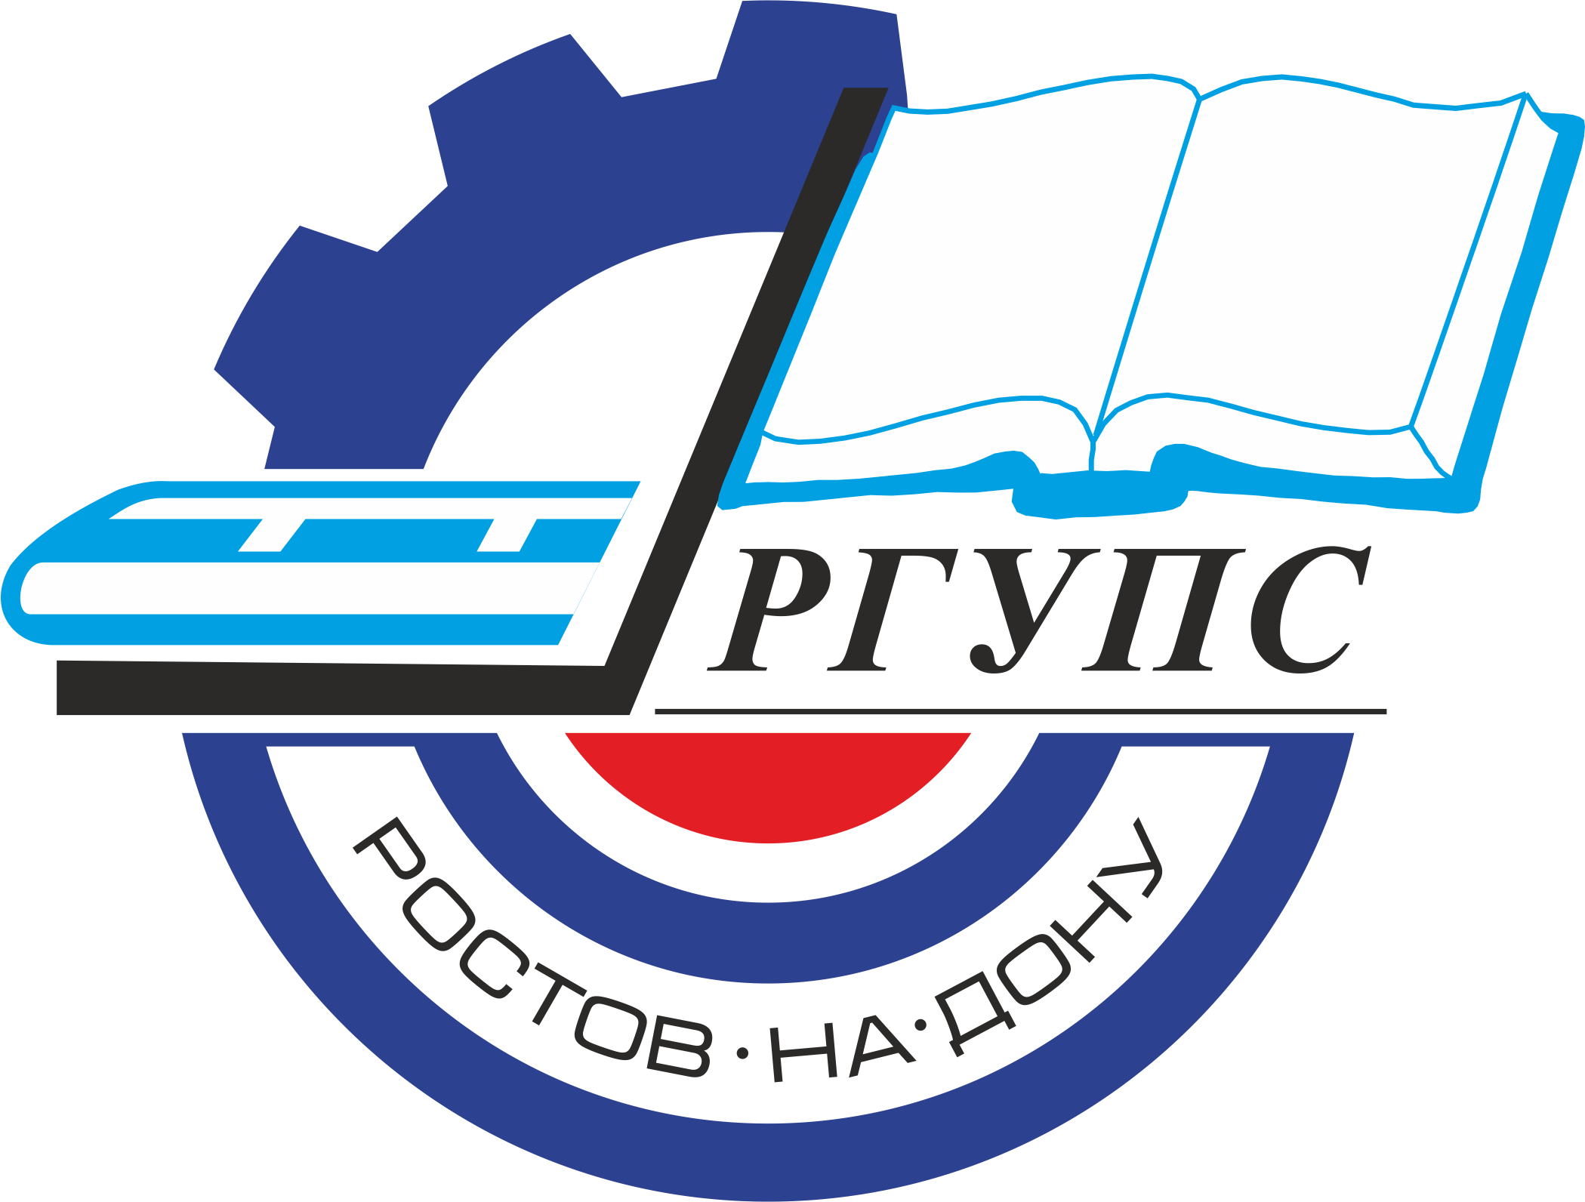 | Rostov State Transport University
International Conference
«Engineering and Technology in Construction and Operation of the Buildings and Structures»
(May 27-28, 2021, Rostov-on-Don, Russia)

Dear colleagues!
We are pleased to invite you to attend the International Conference «Engineering and Technology in Construction and Operation of the Buildings and Structures».
The organization of the conference is the Federal State Budgetary Educational Institution of Higher Education "Rostov State Transport University". The conference will be held in Rostov-on-Don on May 27-28, 2021.
This conference considers the discussion of modern achievements in the field of construction and operation of the railways, buildings and structures.
The Organizing Committee of the Conference is pleased to invite you to attend the conference and publish papers which are of significant scientific interest, original and previously unpublished. After reviewing, all materials will be published in the journal and will be submitted in SCOPUS for indexing.

SCIENTIFIC SCOPE OF CONFERENCE
Section 1. Construction of the railways, buildings and structures
Section 2. Operation of the railways, buildings and structures
Section 3. Engineering surveys
Section 4. Life cycle maintenance management of the overland transport and technological machinery and equipment during the construction of the infrastructure facilities
Section 5. Improving the efficiency of technical systems and technologies in the construction engineering sector

IMPORTANT DATES:
Conference May 27-28, 2021
Paper Submission in English May 25, 2021
REGISTRATION FEE FOR OUTSIDE PARTICIPANTS – 12000 rubles.

If necessary, the translation into English is paid separately.

ORGANIZING COMMITTEE OF THE CONFERENCE:

Chairman:
A.N. Gudа – Vice-Rector for Science;

Organizing Committee Members:
I.A. Mayba - Dean of the Road Construction Machines Department;
V.V. Karpachevsky - Dean of the Construction Department;
V.V. Shapovalov - Head of the Chair «Transport Machines and Tribotechnics»;
A.N. Chukarin - Head of the Chair «Fundamentals of Machine Design»;
V.M. Prikhodko - Head of the Chair «Descriptive Geometry and Engineering Graphics»;
A.A. Revyakin - Head of the Chair «Research, Design and Construction of Railways»;
S.A. Volyanik - Head of the Chair «Chemistry»;
G.V. Karpachevsky - Head of the Chair «Track and Track Facilities»;
V.E. Zinoviev - Head of the Chair «Operation and Repair of Machines».

Organizing Committee Secretaries:

O.N. Soboleva - Chair «Research, Design and Construction of Railways»

M.A. Burakova - Chair «Fundamentals of Machine Design».

SUBMIT PUBLICATIONS
The submitted materials should be original and previously unpublished and should be associated with one or more scientific scope of the conference. All submitted materials are analyzed by the Organizing Committee of the Conference for quality, novelty and scientific accuracy. All manuscripts submitted are subject to peer review process. The negative review with the reasons for refusal or the positive decision is sent to the author by e-mail. We ask you to send all questions about the verification procedure to the contact address.
MANUSCRIPT PREPARATION GUIDELINES
- The minimum size is 6 pages plus References (font 10, single spacing).
- Use only "portrait" page format.
- The structure of the text of the article must comply with the IMRAD standard(https://xn--80aegcaa6cbngm5a6c1ci.xn--p1ai/razbor-struktury-stati-imrad/)
- Requirements for images
- All images must be clear and legible.
a. If you are submitting an article in English:
– absence of Cyrillic characters in the paper (including formulas, graphs, diagrams, diagrams, screenshots of programs and any images) !!!

If you submit paper in Russian:
– all formulas, graphs, diagrams must be editable for translation.
- The sources of borrowing of all images should be indicated, if they are not copyright. The borrowing source is indicated in the figure caption.
- All papers will be checked for plagiarism. In case of detection of plagiarism (as well as self-plagiarism), the authors will be refused to resubmit the paper.

The papers are considered only in English.

CONTACTS
Official Conference Website: http://rgups.ru/science/doktorantura-i-aspirantura-kon-1388/
E-mail: sobolevao@yandex.ru

