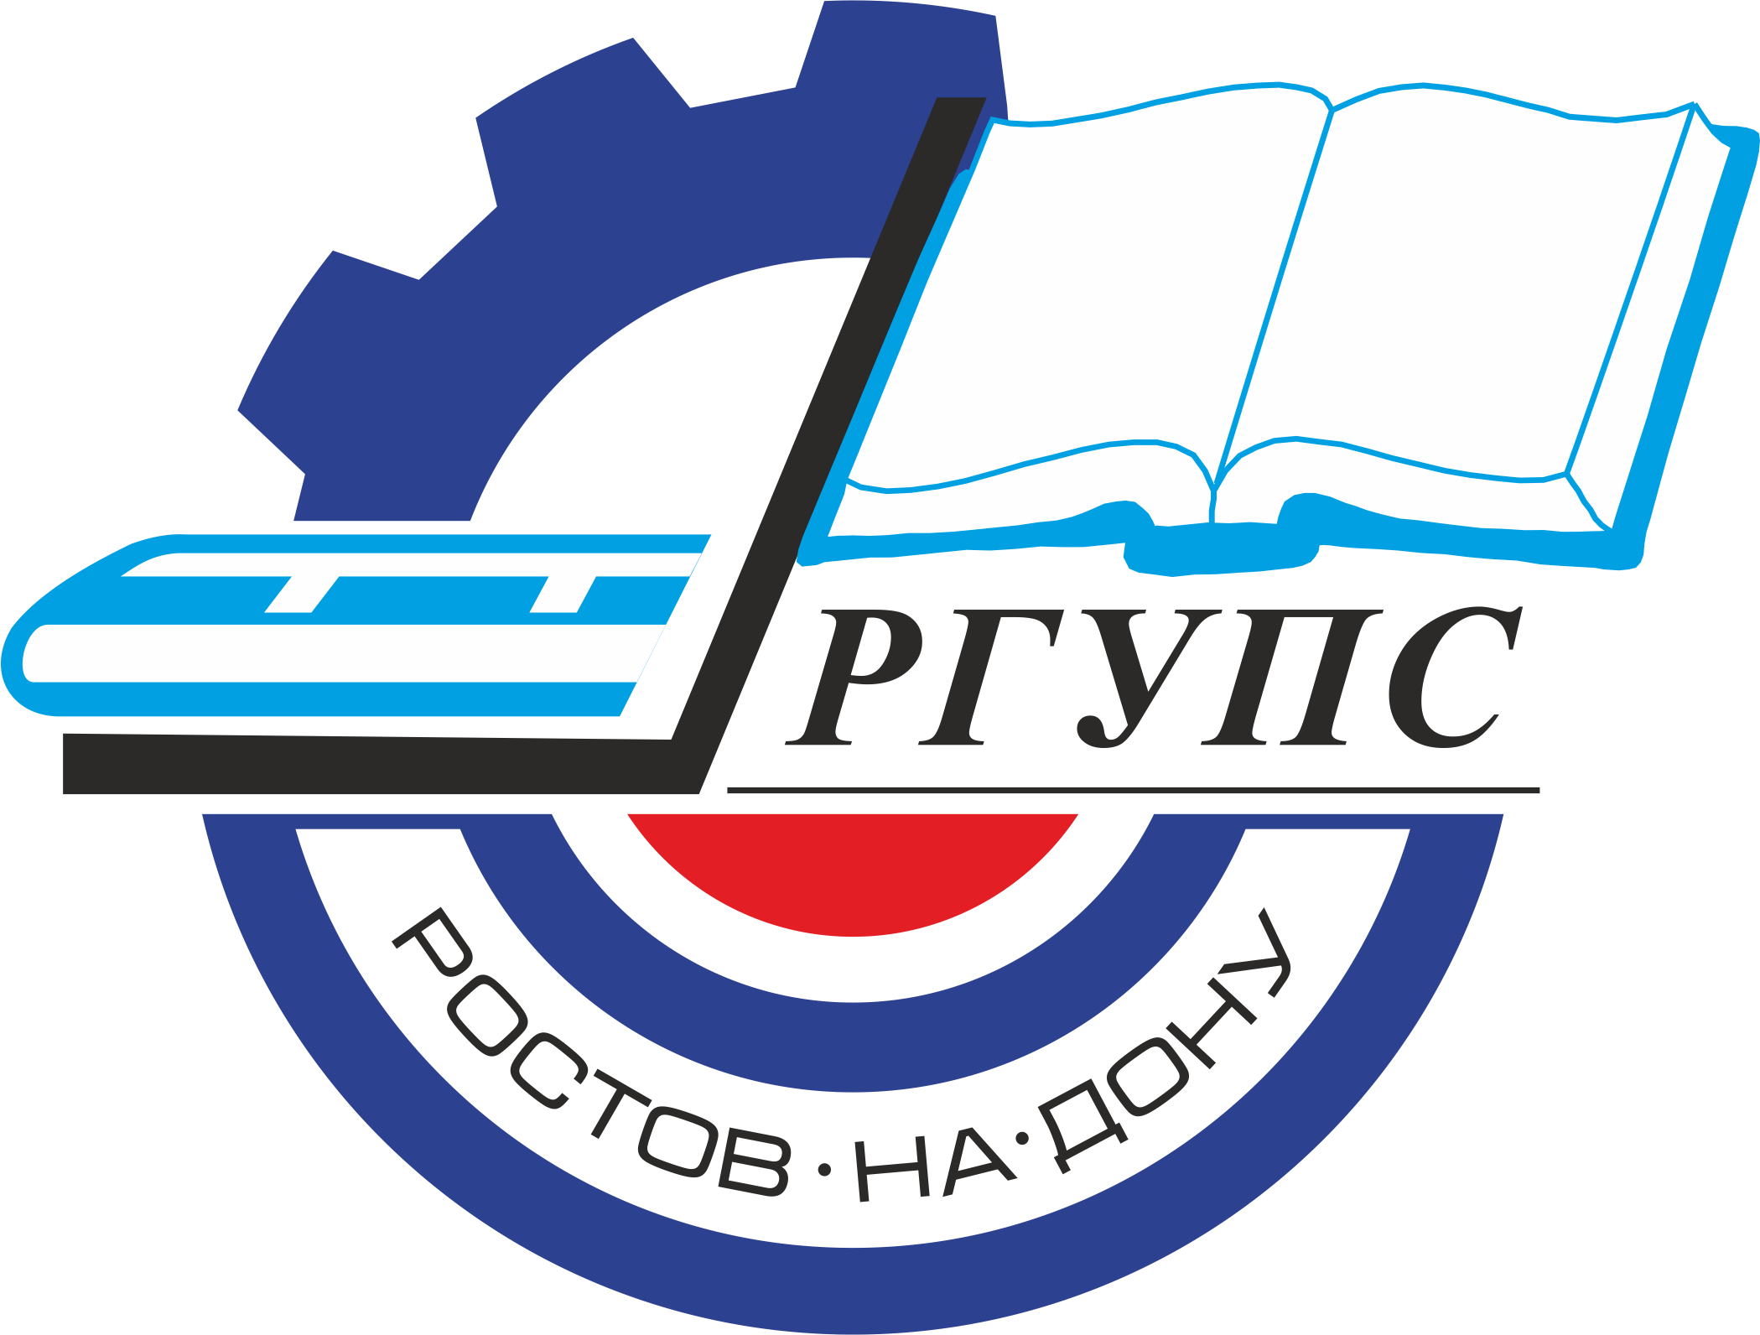 | Rostov State Transport University | 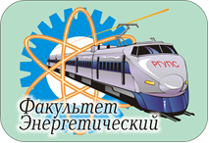

International Research and Practice Conference
«Transportation Energy»
(May 19-20, 2021, Rostov-on-Don, Russia)

Dear colleagues!
We are pleased to invite you to attend the International Research and Practice Conference «Transportation Energy».
The organization of the conference is the Federal State Budgetary Educational Institution of Higher Education "Rostov State Transport University". The conference will be held in Rostov-on-Don on May 19-20, 2021.
The purpose of the conference is to promote informing scientists and practitioners about the most promising areas of research and achievements in the field of transport energy.
The Organizing Committee of the Conference is pleased to invite you to attend the conference and publish papers which are of significant scientific interest, original and previously unpublished. After reviewing, all materials will be published in the journal and will be submitted in SCOPUS for indexing.

SCIENTIFIC SCOPE OF CONFERENCE

- Electric power infrastructure of the railway transport.
- Energy-saving technologies, industrial and environmental safety.
- Electrical machines and electric drive.

IMPORTANT DATES:
Conference May 19-20, 2021
Paper Submission in English May 19, 2021
REGISTRATION FEE FOR OUTSIDE PARTICIPANTS – 12000 rubles.

If necessary, the translation into English is paid separately.

ORGANIZING COMMITTEE OF THE CONFERENCE:

Chairman:
A.N. Gudа - Vice-Rector for Science;

Vice-chairman:
V.A. Finochenko - Dean of Power Supply Faculty;

Scientific secretary:
A.V. Boyko A.V. - Engineer of the Chair «Theoretical Foundations of Electrical Engineering»;

Organizing Committee Members:
P.G. Kolpakhchyan - Head of the Chair «Electrical Machines and Devices»;
V.A. Osipov - Head of the Chair «Theoretical Foundations of Electrical Engineering»;
T.L. Ripoll-Saragossi - Head of the Chair «Heat Power Railway Engineering»;
N.A. Popova - Head of the Chair «Automated Power Supply Systems».

SUBMIT PUBLICATIONS ПОДАЧА ПУБЛИКАЦИЙ
The submitted materials should be original and previously unpublished and should be associated with one or more scientific scope of the conference. All submitted materials are analyzed by the Organizing Committee of the Conference for quality, novelty and scientific accuracy. All manuscripts submitted are subject to peer review process. The negative review with the reasons for refusal or the positive decision is sent to the author by e-mail. We ask you to send all questions about the verification procedure to the contact address.
MANUSCRIPT PREPARATION GUIDELINES
- The minimum size is 6 pages plus References (font 10, single spacing).
- Use only "portrait" page format.
- The structure of the text of the article must comply with the IMRAD standard(https://xn--80aegcaa6cbngm5a6c1ci.xn--p1ai/razbor-struktury-stati-imrad/)
- Requirements for images
- All images must be clear and legible.
a. If you are submitting an article in English:
– absence of Cyrillic characters in the paper (including formulas, graphs, diagrams, diagrams, screenshots of programs and any images) !!!

If you submit paper in Russian:
– all formulas, graphs, diagrams must be editable for translation.
- The sources of borrowing of all images should be indicated, if they are not copyright. The borrowing source is indicated in the figure caption.
- All papers will be checked for plagiarism. In case of detection of plagiarism (as well as self-plagiarism), the authors will be refused to resubmit the paper.

The papers are considered only in English.

CONTACTS
Official Conference Website:
E-mail: energo@rgups.ru

