 | 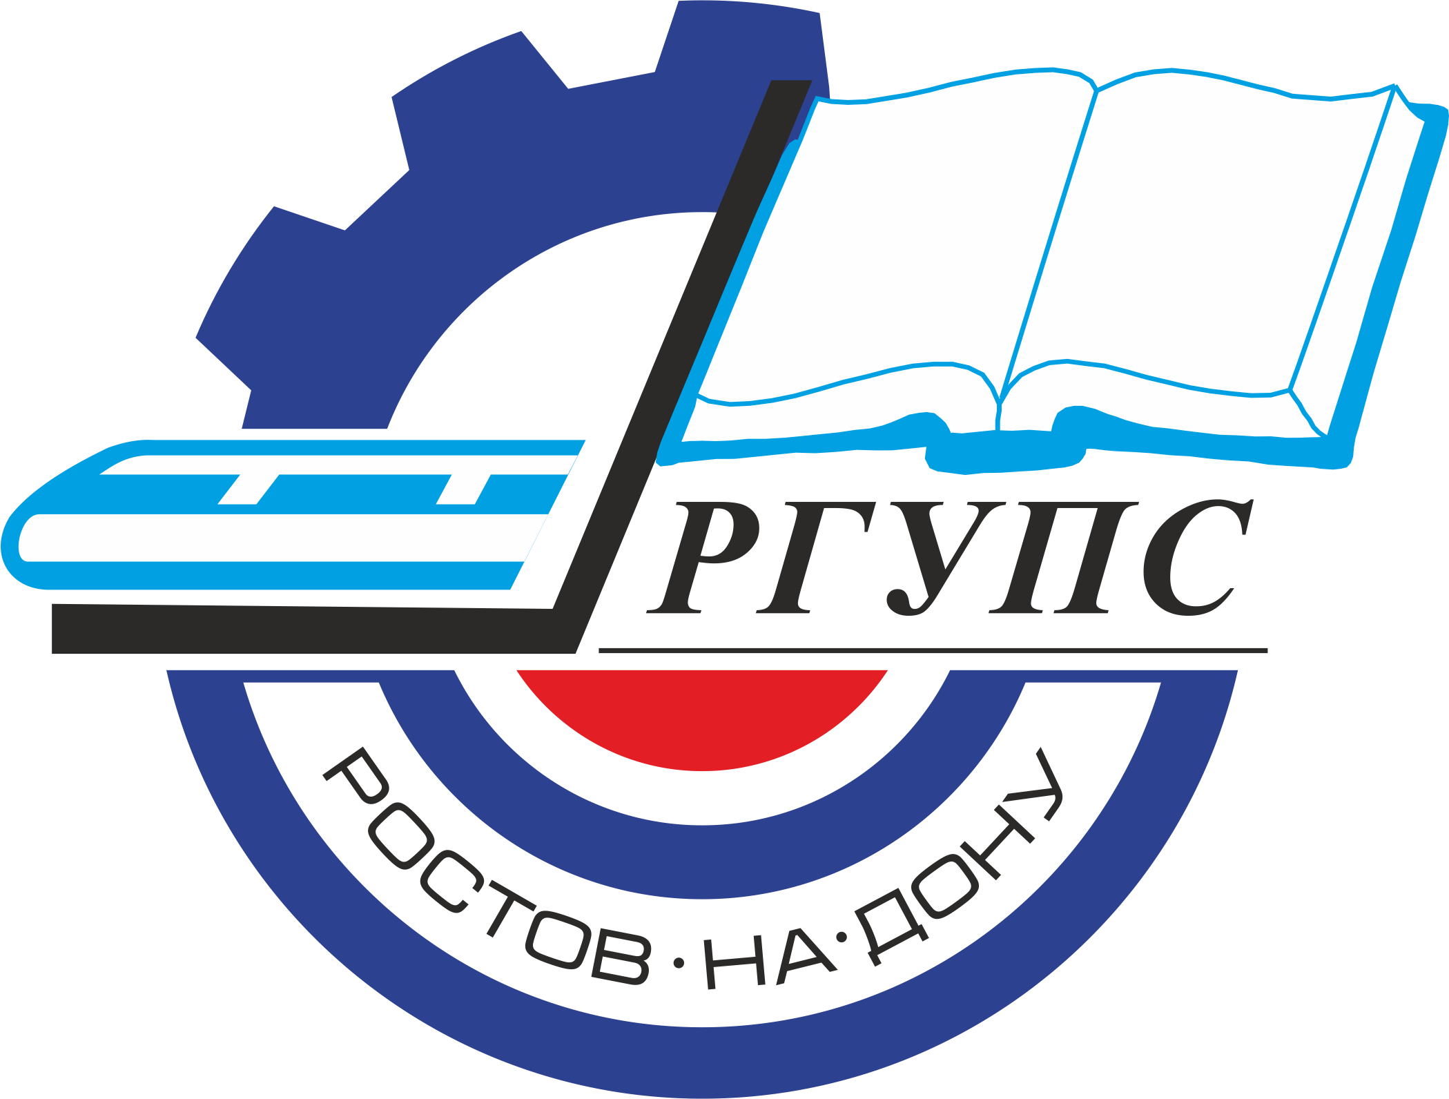 | Rostov State Transport University
International Multidisciplinary Research and Practice Conference
«Actual Problems and Prospects for the Development of Locomotive and Car Building and Rolling Stock Maintenance Technology»
(May 17-18, 2021, Rostov-on-Don, Russia)

Dear colleagues!
We are pleased to invite you to attend the International Multidisciplinary Research and Practice Conference «Actual Problems and Prospects for the Development of Locomotive and Car Building and Rolling Stock Maintenance Technology».
The organization of the conference is the Federal State Budgetary Educational Institution of Higher Education "Rostov State Transport University". The conference will be held in Rostov-on-Don on May 17-18, 2021.
This conference considers the discussion of modern achievements in the field of the transport engineering, technological processes and rolling stock. The conference is organized with aim of supporting interdisciplinary discussion and publication the results of the research summarizing achievements in engineering field in higher educational institutions, research institutes, large industrial enterprises, research and production associations of the Russian Federation as well as foreign authors, and the research results carried out personally.
The purpose of the conference is to assist in informing scientists and practitioners about the most promising areas of research and achievements in the field of the transport engineering and technological processes of rolling stock.

The Organizing Committee of the Conference is pleased to invite you to attend the conference and publish papers which are of significant scientific interest, original and previously unpublished. After reviewing, all materials will be published in the journal and will be submitted in SCOPUS for indexing.

SCIENTIFIC SCOPE OF CONFERENCE
1. Railway Rolling Stock, thematic sections:
1.1 Modern solutions for innovative freight and passenger rolling stock.
1.2 Advanced technologies for traction rolling stock.
1.3 Energy efficiency of the rolling stock and transportation process.
1.4 High-speed land transport and high-speed communication technologies.
1.5 Power electronics, electrical machines and electric drives.

2. Intelligent Control Systems and Automation of Technological Processes and Objects of the Transport Complex, thematic sections:
2.1 Mechatronic, robotic and electromechanical systems and complexes.
2.2 Information technology in railway transport.
2.3 Intelligent control systems for rolling stock.
2.4 Automation of technological processes and facilities.
2.5 Modeling technical systems and processes.

3. Labor and environmental protection at the enterprises of the machine-building and transport complex, thematic sections:
3.1 "Green technologies" in transport.
3.2 Environmental protection systems.
3.3 Transport and technosphere safety.
3.4 Risk-based approach in the management of the technosphere safety.
3.5 Protection systems against physical factors.

4. Mechanical engineering, thematic sections:
4.1 Intelligent and innovative technologies in the production and repair of rolling stock.
4.2 Engineering of the transport machinery.
4.3 Transport and technological machines and equipment of the machine-building enterprises.
4.4 Materials science, new and advanced materials and coatings.
4.5 Friction and wearing in transport and technological systems.

IMPORTANT DATES:
Conference May 17-18, 2021
Paper Submission in English May 17, 2021
REGISTRATION FEE FOR OUTSIDE PARTICIPANTS – 12000 rubles.

If necessary, the translation into English is paid separately.

ORGANIZING COMMITTEE OF THE CONFERENCE:

Chairman:
A.N. Gudа - Vice-Rector for Science;

Vice-chairman:
I.A. Yayckov I.A. - Dean of Electromechanical Faculty;

Organizing Committee Members:
A.E. Bogoslavsky - Head of the Chair «Traction Rolling Stock»;
O. A. Voron - Head of the Chair «Cars and Car Facilities»
T.A. Finochenko - Head of the Chair «Health and Safety»;
V.N. Krotov - Acting Head of the Chair «Technology of Metals»;
A.E. Nabokov - Deputy Dean of the Faculty of Electromechanical, Deputy Head of the Chair «Construction Mechanics»;
A.V. Sidashov - Deputy Head of the Chair «Theoretical Mechanics»;
A.V. Kostyukov - Head of the Department «Doctorate and Postgraduate Studies»;
A.A. Nazaretov - Deputy Director of the Scientific-Research Department, Chair «Cars and Car Facilities»;

Organizing Committee Secretaries:
T.Z. Talakhadze - Chair «Traction Rolling Stock»;
I.V. Bolshikh - Chair «Traction Rolling Stock».

SUBMIT PUBLICATIONS ПОДАЧА ПУБЛИКАЦИЙ
The submitted materials should be original and previously unpublished and should be associated with one or more scientific scope of the conference. All submitted materials are analyzed by the Organizing Committee of the Conference for quality, novelty and scientific accuracy. All manuscripts submitted are subject to peer review process. The negative review with the reasons for refusal or the positive decision is sent to the author by e-mail. We ask you to send all questions about the verification procedure to the contact address.
MANUSCRIPT PREPARATION GUIDELINES
- The minimum size is 6 pages plus References (font 10, single spacing).
- Use only "portrait" page format.
- The structure of the text of the article must comply with the IMRAD standard(https://xn--80aegcaa6cbngm5a6c1ci.xn--p1ai/razbor-struktury-stati-imrad/)
- Requirements for images
- All images must be clear and legible.
a. If you are submitting an article in English:
– absence of Cyrillic characters in the paper (including formulas, graphs, diagrams, diagrams, screenshots of programs and any images) !!!

If you submit paper in Russian:
– all formulas, graphs, diagrams must be editable for translation.
- The sources of borrowing of all images should be indicated, if they are not copyright. The borrowing source is indicated in the figure caption.
- All papers will be checked for plagiarism. In case of detection of plagiarism (as well as self-plagiarism), the authors will be refused to resubmit the paper.

The papers are considered only in English.

CONTACTS
Official Conference Website: http://rgups.ru/science/doktorantura-i-aspirantura-kon-1388/
E-mail: konf_ps@rgups.ru
Tel.:

